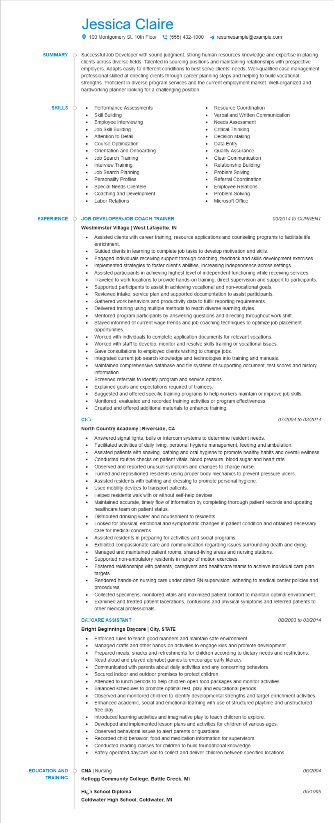
SUMMARY
Jessica Claire
100 Montgomery St. 10th Floor (555) 432-1000
resumesample@example.com
Successful Job Developer with sound judgment, strong human resources knowledge and expertise in placing clients across diverse fields. Talented in sourcing positions and maintaining relationships with prospective employers. Adapts easily to different conditions to best serve clients' needs. Well-qualified case management professional skilled at directing clients through career planning steps and helping to build vocational strengths. Proficient in diverse program services and the current employment market. Well-organized and hardworking planner looking for a challenging position.
SKILLS O
•
Performance Assessments
•
Skill Building
•
Employee Interviewing
Job Skill Building
•
Resource Coordination
Verbal and Written Communication
Needs Assessment
Critical Thinking
Decision Making
Attention to Detail
.
Course Optimization
•
Data Entry
Orientation and Onboarding
Quality Assurance
Job Search Training
•
Interview Training
•
Job Search Planning
Personality Profiles
Special Needs Clientele
Coaching and Development
Labor Relations
Clear Communication
Relationship Building
Problem Solving
Referral Coordination
Employee Relations Problem-Solving
•
Microsoft Office
EXPERIENCE Ó JOB DEVELOPER/JOB COACH TRAINER
Westminster Village | West Lafayette, IN
•
03/2014 to CURRENT
Assisted clients with career training, resource applications and counseling programs to facilitate life enrichment.
Guided clients in learning to complete job tasks to develop motivation and skills.
Engaged individuals receiving support through coaching, feedback and skills development exercises. Implemented strategies to foster client's abilities, increasing independence across settings.
Assisted participants in achieving highest level of independent functioning while receiving services. Traveled to work locations to provide hands-on training, direct supervision and support to participants. Supported participants to assist in achieving vocational and non-vocational goals.
EDUCATION AND
TRAINING
•
Reviewed intake, service plan and supported documentation to assist participants.
Gathered work behaviors and productivity data to fulfill reporting requirements.
Delivered training using multiple methods to reach diverse learning styles.
•
•
Mentored program participants by answering questions and directing throughout work shift.
Stayed informed of current wage trends and job coaching techniques to optimize job placement opportunities.
Worked with individuals to complete application documents for relevant vocations.
Worked with staff to develop, monitor and resolve skills training or vocational issues.
Gave consultations to employed clients wishing to change jobs.
Integrated current job search knowledge and technologies into training and manuals.
Maintained comprehensive database and file systems of supporting document, test scores and history information.
Screened referrals to identify program and service options.
Suggested and offered specific training programs to help workers maintain or improve job skills.
Explained goals and expectations required of trainees.
Monitored, evaluated and recorded training activities or program effectiveness.
•
Created and offered additional materials to enhance training.
сла
North Country Academy | Riverside, CA
07/2004 to 03/2014
Answered signal lights, bells or intercom systems to determine resident needs.
•
Facilitated activities of daily living, personal hygiene management, feeding and ambulation.
•
Assisted patients with shaving, bathing and oral hygiene to promote healthy habits and overall wellness. Conducted routine checks on patient vitals, blood pressure, blood sugar and heart rate.
•
Observed and reported unusual symptoms and changes to charge nurse.
•
Turned and repositioned residents using proper body mechanics to prevent pressure ulcers.
Assisted residents with bathing and dressing to promote personal hygiene.
Used mobility devices to transport patients.
•
Helped residents walk with or without self-help devices.
Maintained accurate, timely flow of information by completing thorough patient records and updating healthcare team on patient status.
Distributed drinking water and nourishment to residents.
• Looked for physical, emotional and symptomatic changes in patient condition and obtained necessary care for medical concerns.
•
Assisted residents in preparing for activities and social programs.
Exhibited compassionate care and communication regarding issues surrounding death and dying. Managed and maintained patient rooms, shared-living areas and nursing stations.
• Supported non-ambulatory residents in range of motion exercises.
Fostered relationships with patients, caregivers and healthcare teams to achieve individual care plan targets
Rendered hands-on nursing care under direct RN supervision, adhering to medical center policies and procedures.
Collected specimens, monitored vitals and maximized patient comfort to maintain optimal environment. Examined and treated patient lacerations, contusions and physical symptoms and referred patients to other medical professionals.
DAOCARE ASSISTANT
Bright Beginnings Daycare | City, STATE
08/2003 to 03/2014
Enforced rules to teach good manners and maintain safe environment.
•
Managed crafts and other hands-on activities to engage kids and promote development. Prepared meals, snacks and refreshments for children according to dietary needs and restrictions. Read aloud and played alphabet games to encourage early literacy.
Communicated with parents about daily activities and any concerning behaviors.
•
Secured indoor and outdoor premises to protect children.
•
Attended to lunch periods to help children open food packages and monitor activities
Balanced schedules to promote optimal rest, play and educational periods.
•
Observed and monitored children to identify developmental strengths and target enrichment activities.
Enhanced academic, social and emotional learning with use of structured playtime and unstructured free play.
Introduced learning activities and imaginative play to teach children to explore.
•
Developed and implemented lesson plans and activities for children of various ages.
Observed behavioral issues to alert parents or guardians.
Recorded child behavior, food and medication information for supervisors.
Conducted reading classes for children to build foundational knowledge.
Safely operated daycare van to collect and deliver children between specified locations.
OCNA | Nursing
06/2004
Kellogg Community College, Battle Creek, MI
High School Diploma
Coldwater High School, Coldwater, MI
05/1995

